Type of Triangle | HackerRank
Question:
Write a query identifying the type of each record in the TRIANGLES table using its three side lengths. Output one of the following statements for each record in the table:
- Equilateral: It's a triangle with sides of equal length.
- Isosceles: It's a triangle with sides of equal length.
- Scalene: It's a triangle with sides of differing lengths.
- Not A Triangle: The given values of A, B, and C don't form a triangle.
Input Format
The TRIANGLES table is described as follows:
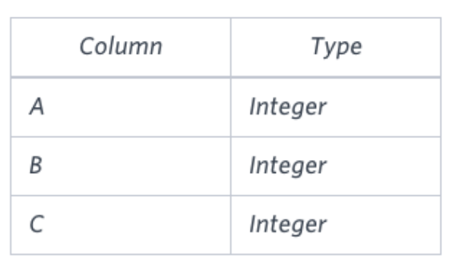
Each row in the table denotes the lengths of each of a triangle's three sides.
Sample Input
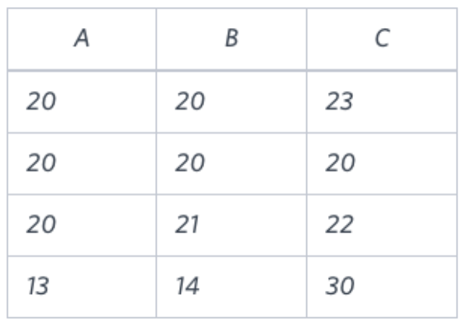
Sample Output
Isosceles
Equilateral
Scalene
Not A Triangle
Explanation
- Values in the tuple (20,20,23) form an Isosceles triangle, because A=B.
- Values in the tuple (20,20,20) form an Equilateral triangle, because A=B=C.
- Values in the tuple (20,21,22) form a Scalene triangle, because A!=B!=C.
- Values in the tuple (13,14,30) cannot form a triangle because the combined value of sides A and B is not larger than that of side C.
My Answer:
SELECT
case
when (A = B and B = C) then 'Equilateral'
when ((A = B or B = C or A=C) and
((A>B and A>C and B+C>A)or
(B>C and B>A and A+C>B)or
(C>A and C>B and A+B>C))) then 'Isosceles'
when ((A>B and A>C and B+C>A)or
(B>C and B>A and A+C>B)or
(C>A and C>B and A+B>C)) then 'Scalene'
else 'Not A Triangle'
end as name_triangle
from triangles;

Answer 2: Short Version
SELECT
case
when (A+B>C and A+C>B and B+C>A) then
case
when(A=B and B=C) then 'Equilateral'
when(A=B or B=C or A=C) then 'Isosceles'
else 'Scalene'
end
else 'Not A Triangle'
end as Name_Triangle
from Triangles;

